HD 68988

HD 68988 is a 1.2 M☉, G0 star1. Based on 65 RV HIRES measurements obtained between 2000 and 2020 and 6 RV Lick measurements obtained between January and February 2001, the CL survey reported a Hot Jupiter (HD 68988b) signal with a period of 6.27642 ± 0.00001 days, a minimum mass of MJup and an eccentricity of as well as a LPGP (HD 68988c) signal with a period of days, a minimum mass of MJup and an eccentricity of .

In the present study, the CL survey's dataset was used. DPASS and MCMC (1000 walkers and 400000 iterations) were used to fit the data. To converge more easily, the priors on the semi-major axis and the minimum mass of HD 68988b were close to the values found in the CL survey. The properties found for HD 68988b are, expectedly, close to those reported in the CL survey. For HD 68988c, a period of 12190 days, a minimum mass of 13.9 MJup and an eccentricity of 0.34 were found with DPASS, with a corresponding rms of residuals of 4.2 m/s and a period between 13200 and 44800 days, a minimum mass between 14 and 21MJup and an eccentricity between 0.37 and 0.68 were found using MCMC. As the RV curve of HD 68988c covers only a minimum, the RV offset is not well constrained, though.

To explore the range of possible values for these parameters, the stellar offset was fixed to different values and the data, once corrected for the instrumental offsets for clarity purposes, were fitted with DPASS. Stellar offset up to 175 m/s do not significantly change the rms of the residuals (5 m/s against 4.2 m/s with offset left free). In this case (referred to as constrained offset), the semi-major axis is 47.5 au, the minimum mass is 28.6 MJup and the high eccentricity is 0.8. However, changing the semi-major axis does not change the possible solutions beyond those found with the constrained offset.

The fits are shown in Fig 1, and the corner plot in Fig 2, and the results summarized in Table 1.

Conclusion: The properties found in the CL survey for HD 68988c are not confirmed. Depending on the stellar offset, the companion could be a brown dwarf. Additional data are needed to further constrain its orbital properties.

Figure 1: Left: fit of the HD 68988 RV with DPASS. Red - Hir94, green - Hir04, blue - LICK. The blue curve shows the best fit. Middle: fit of the HD 68988 RV with DPASS, with a subtracted stellar offset fixed to 175 m/s. Black points correspond to the data corrected for the instrumental offsets. The blue curve shows the best fit. Right: fit of the HD 68988 RV using MCMC. The black curve shows the best fit. 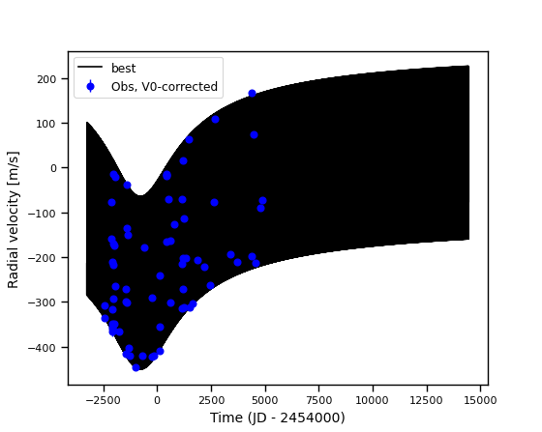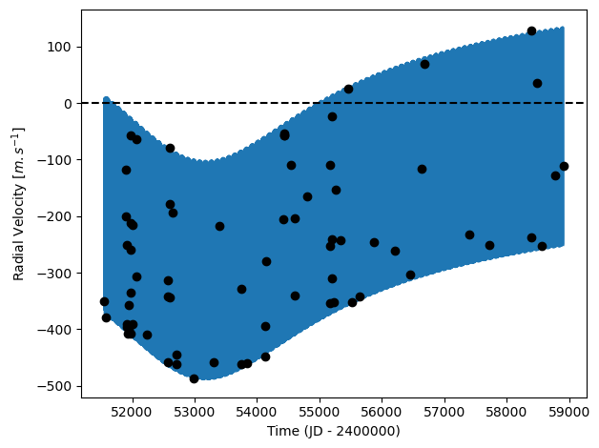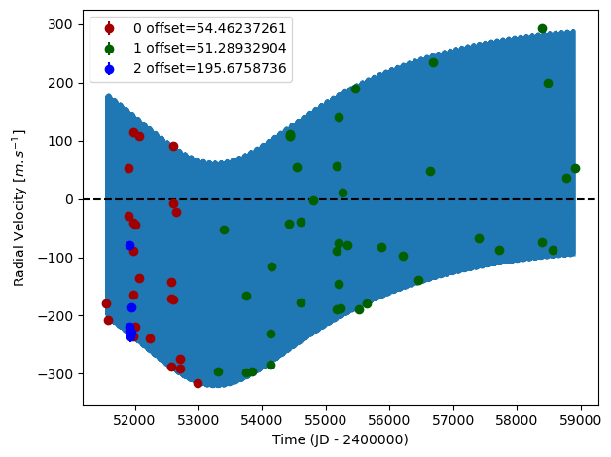

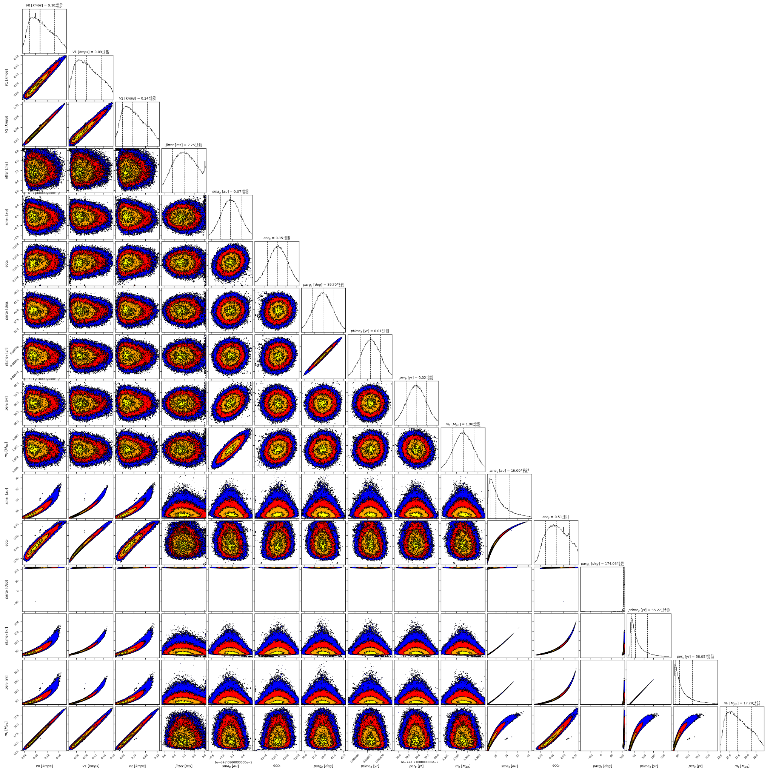

Figure 2: Corner plot of posteriors for the two-planets model MCMC fit of HD 68988 RV data.

| Parameter | Priors | | | Posteriors | | | CL survey |
| --- | --- | --- | --- | --- | --- | --- | --- |
|  | DPASS | | MCMC | DPASS | | MCMC |  |
|  | Free offset | Constrained offset | Free offset | Free offset | Constrained offset | Free offset |  |
| *a* (au) | b: [0,1]  c: [0,100] | b: [0,0.1]  c: [0,100] | b: [0.06,0.08]  c: [1,100] | b = 0.07  c = 11.1 | b = 0.07  c = 47.5 | b = 0.071 ± 0.001  c = 11.6 – 26 | b =  c = |
| Msin(i) (MJup) | b: [0,10]  c: [0,100] | b: [0,2.5]  c: [0,100] | b: [1,3]  c: [5,100] | b = 1.96  c = 13.9 | b = 2  c = 28.6 | b = 1.96 ± 0.01  c = 14 – 21 | b =  c = |
| Eccentricity | b: [0,0.9]  c: [0,0.95] | b: [0,0.2]  c: [0,0.95] | b: [0,0.3]  c: [0,0.95] | b = 0.15  c = 0.34 | b = 0.15  c = 0.8 | b = 0.15 ± 0.01  c = 0.37 – 0.68 | b =  c = |
| Instrumentals offsets (km/s) | [-100,100] | fixed to 0.175 | [-1,1] | Hir94: 0.055  Hir04: 0.051  LICK: 0.196 | 0.175 | Hir94: 0.059 – 0.145  Hir04: 0.057 – 0.143  Apf: 0.200 – 0.287 |  |
| Stellar jitter (m/s) | [0,40] | [0,40] | [0,10] | 5.8 | 6.9 |  |  |
| Argument of periastron (°) | b: [0,360]  c: [0,360] | b: [0,360]  c: [0,360] | b: [0,360]  c: [0,360] | b = 40  c = 171 | b = 40  c = 170 | b =  c = 170 – 177 |  |
| Phase | b: [0,1]  c: [0,1] | b: [0,1]  c: [0,1] | b: [0,1]  c: [0,1] | b = 0.89  c = 0.36 | b = 0.90  c = 0.49 | b = 0.50 ± 0.01  c = |  |

Table 1: HD 68988. Summary of priors and posteriors obtained with DPASS and MCMC, compared to the properties reported by the CL Survey.

References

1. Fischer, D. and Valenti, J. The Planet-Metallicity Correlation. *Astrophys. J.* 622, 1102-1117 (2005).